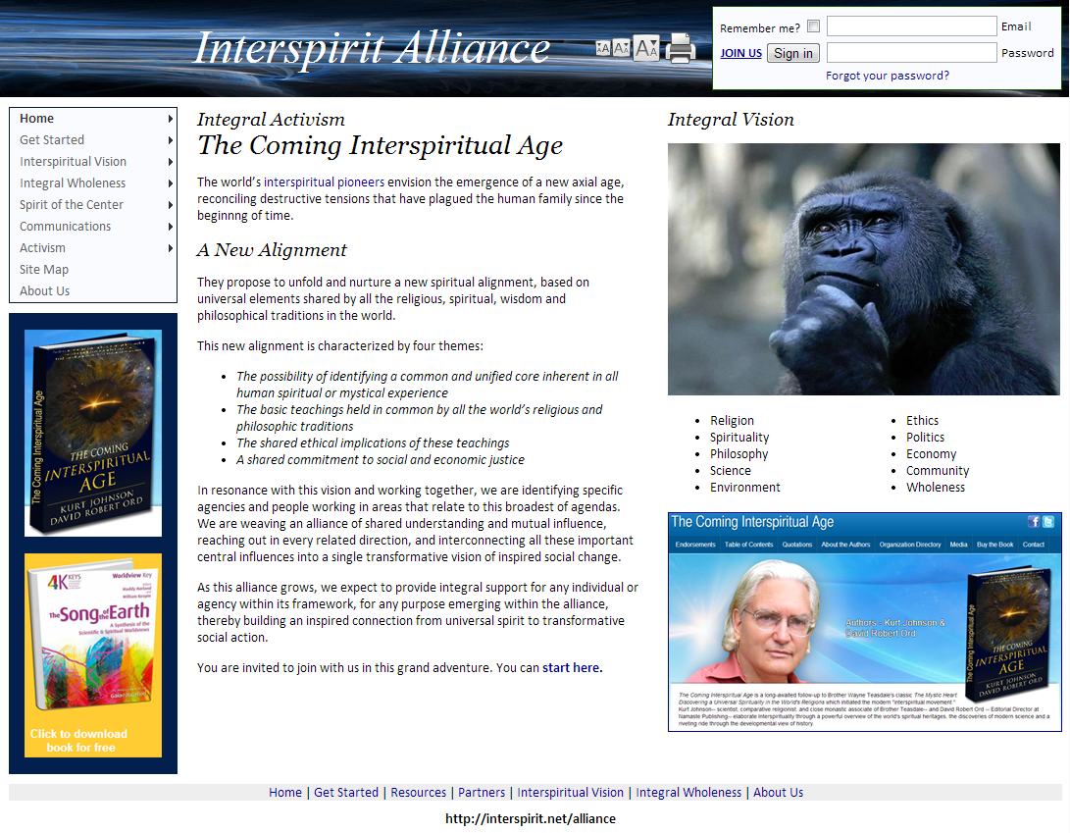
Interspirit Alliance
http://interspirit.net/alliance

As a rather sudden and explosive outgrowth of many years of working in interfaith and network development, and inspired by the new book by Dr. Kurt Johnson and the Dawn of Interspirituality conference, the Interspirit Alliance is unfolding as a full-featured “intranet” system for coordinating a global movement of “Interspiritual Pioneers.”
Our internet platform can support a broad range of co-creative activities, taking on the full range of issues outlined in our basic agenda, as defined on our home page. We can organize a systematic and methodical search for the common ground among all religions and spiritual traditions, while incorporating science and humanism. The site is organized around a vision of who and what we are as Interspiritual Pioneers, and what we see and believe and want to do together. This vision is presented in the form of a hypothesis (“The Integral Hypothesis”) – as a working collaborative document-in-process that attempts to gather into one place all the widely diverse core elements of this very broad and inclusive movement. The site works to define our common ground, and to synthesize from all contributing sources a body of shared understanding and agreement around which our community can resonate.
With extensive experience in new-democracy political organizing, as well as in interfaith development, we are well-positioned to support an activist movement for “spirit-led social change”. We have the tools to take on any issue that arises for our members. We can help organize circles and local groups anywhere. We have forums, newsletters, and polling systems to help us define our leading points of agreement. We are linked to NCDD (National Coalition on Dialogue and Deliberation), the leading professional association for Appreciative Inquiry, World Café, community circles and general group process. We are building a database of related Wikipedia pages and resources.
We want to serve the emerging Interspiritual Movement in every way possible. We want to hear from you, we want to be in touch with you, we want your contact information (name, phone number, email address, location, web site), and we want to help network the community that emerges from this Dawn of Interspirituality conference. Thanks for being here, thanks for your passion, for your vision, for your caring heart…
Bruce Schuman
Bruce Schuman is an interfaith worker and web system developer with a background in cognitive science, who has been developing innovative and leading-edge internet projects on religion and spirituality since 1993. He has worked with the Parliament of World Religions and was a delegate to the Assembly of Religious Leaders at Montserrat in 2004. He attended the Goldin Institute meeting in Manresa in 2003 and the From Conflict to Trust conference at Oxford in 2001. He built the initial “cooperation circle” network for the United Religions Initiative. In the late 1990’s, working with Rev. Gloria Weber, he built Interfaith Voices for Peace and Justice. Working with Joel Beversluis, author of SourceBook for Earth’s Community of Religions, he developed the World Interfaith Congress. In 1998, he built the Conscious Evolution Network system for Barbara Marx Hubbard and her local community in Santa Barbara. In 2002, seeing the similarity in these projects, and fascinated with the emerging concept of interspirituality, he developed the Interspirit system, an integrated database/network framework that has supported the CPWR, URI, NAIN (North American Interfaith Network) and the Interfaith Initiative of Santa Barbara Country as well as Conscious Evolution, LightPages, Network of Circles, Global Resonance Network, Gather the Women and Standing Women. His other projects include The Bridge Across Consciousness, United Communities of Spirit and the Urantia Book Readers Online Network. In 2010, he built the Shared Purpose network system to support co-creative approaches to national political organizing. His technical work on algebraic semantics is linked from Origin Research.
Bruce Schuman, bruceschuman@cox.net
PO Box 23346, Santa Barbara CA
(805) 966-9515

